ITALIAN 446 (in Italian)
Marginal Masculinities: Contesting the Latin Lover in Post-War Italy

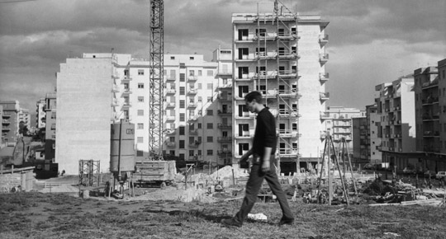
This course looks at the depiction of masculinity in Italian films in the decades after World War II. We start with a discussion of Italian Fascism, focusing on its rhetoric of virility and violence. In particular, students will trace how the regime used visual media –photography, sculpture and cinema– in order to invent its ideal man - bellicose, reproductive and macho. Which men were considered worthy of imitation? Alternately, whose bodies were said to dilute the nation’s potency? With this as a backdrop, we then turn to cinematic and fictional representations of manhood in the post-war years. Students will analyze films in light of historical context, imagery and narrative structure. If the Fascist state tried to define acceptable borders of “manliness” through state-funded cinema, film directors after the war often used the camera to question inherited icons of manliness. In this class, we will learn about the ways that cinema has framed and contested prevailing gender roles
COURSE REQUIREMENTS:
In this class, students will pay close attention to the relations between visual form and content, between film and viewer. Written assignments and in-class activities will help us learn how to engage critically with a cinematic work. Students are expected to attend class regularly, coming ready to discuss all assigned films and readings. Graded assignments will include short (5-7 page) argumentative essays. In preparation for these essays, students will first complete a number of ungraded response papers. In order to improve our analytical writing, all assignments will be peer-reviewed in class before the due date. After the first week, a pair of students will lead class discussion for twenty minutes during each meeting.

POSSIBLE FILMS:
Scipio, l’africano (1937), Carmine Gallone
Ossessione (1949), Luchino Visconti
Il bell’Antonio (1960), Mauro Bolognini
La Dolce Vita (1960), Frederico Fellini
Rocco e i suoi fratelli (1960), Luchino Visconti
La notte (1961), Michelangelo Antonioni
Accattone (1961), Pier Paolo Pasolini
Divorzio all’italiana (1961), Pietro Germi
Eclisse (1962), Michelangelo Antonioni
Teorema (1968), Pier Paolo Pasolini
Una giornata particolare (1977), Ettore Scola
NOVELS:
Bell’Antonio (1949), Vitaliano Brancati
SECONDARY READINGS (SOME EXCERPTED):

Film under Fascism:

The Enemy of the New Man: Homosexuality in Fascist Italy, Lorenzo Benadusi
Re-Viewing Fascism 1922-1943, Jacqueline Reich
“Unmaking the Fascist Man: Masculinity, Film and the Transition from Dictatorship,” Ruth Ben-Ghiat

“Modernity and Masculinity in the Italian Colonial Cinema,” Ruth-Ben Ghiat
Gender and Film in Post-War Italy:
Technologies of Gender: Essays on Theory, Film, and Fiction, Teresa de Lauretis
Beyond the Latin Lover: Marcello Mastroianni, Masculinity and Italian Cinema, Jacqueline Reich
History of Italian Cinema, Gian Piero Brunetta

